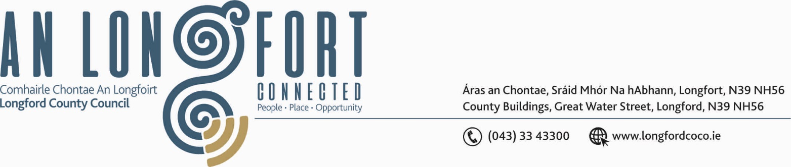

LONGFORD MUNICIPAL DISTRICT

18th June 2020

To: Each Member of Longford Municipal District.

A Chomhairleoir,

You are requested to attend the Annual Meeting of the Longford Municipal District to be held in Sports Hall, Leisure Centre, Albert Reynolds Peace Park, Longford on Wednesday, 24th June 2020 at 2.30 p.m.to transact business, as set out on the Agenda hereunder.


Mise le meas,

_______________
Anne Lee,
Meetings Administrator.

C L A R

1. Election of Cathaoirleach.

2. Election of Leas Cathaoirleach .

3. Fix date and time of Longford Municipal District meetings.



